Question 1:
Scenario: You're developing a simple grade calculator for a school. The teacher wants to input marks for 5 subjects and see the total and average marks.
Task: Write a C++ program that:
- Asks the teacher to enter marks for 5 subjects (out of 100)
- Stores these marks in an array
- Calculates and displays:
- Total marks
- Average marks
- Whether the student passed (average ≥ 50)

Expected Output:
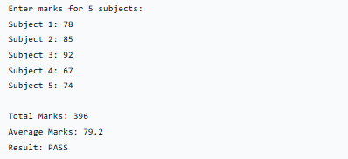
Question 2:
Scenario: You're creating a simple system for a small library to track book information.
Task: Write a C++ program using structures to:
- Create a Book structure with:
- Book ID (integer)
- Book Title (string)
- Author Name (string)
- Price (float)
- Take input for 3 books
- Display all book information
- Calculate and display the total price of all books

Expected Output:
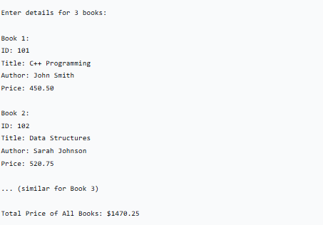
Question:3
Scenario: A college wants to analyze student performance across multiple semesters.
Task: Write a C++ program that:
- Uses a structure Student containing:
- Roll Number
- Name
- Marks in 3 subjects (array of 3 integers)
- CGPA (float)
- Uses dynamic memory allocation to create an array of Student structures
(ask user how many students to enter)
- Write functions for:
- Input student details
- Calculate CGPA (Assume: CGPA = total marks/30)
- Display all students with CGPA ≥ 3.0
- Find and display top performer
- Use pointers to manipulate the student array
- Properly deallocate memory at the end

Expected Output:
